Test Case: tc003_SPX_Dev5_Crear_Requisicion_Spot_Tipo_Cobro_CC_Urgent
Step 1 - Enter username and password and click to button Enter : Credentials Entered
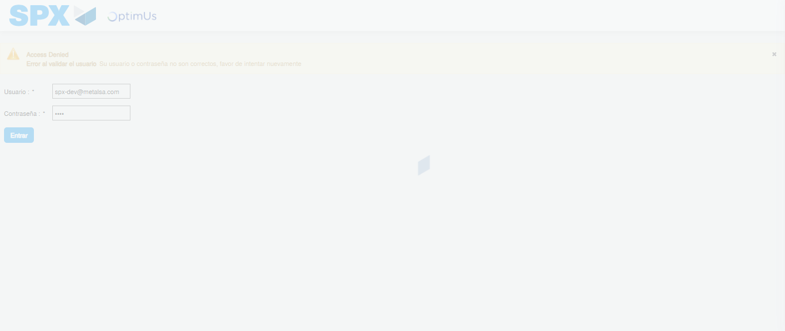Image file-name: QC_Testing-tc003_SPX_Dev5_Crear_Requisicion_Spot_Tipo_Cobro_CC_Urgent-1782239813639

Step 2 - Select to UEN and Access to Spot Buy Requisitions : UEN Correctly selected and Correct access
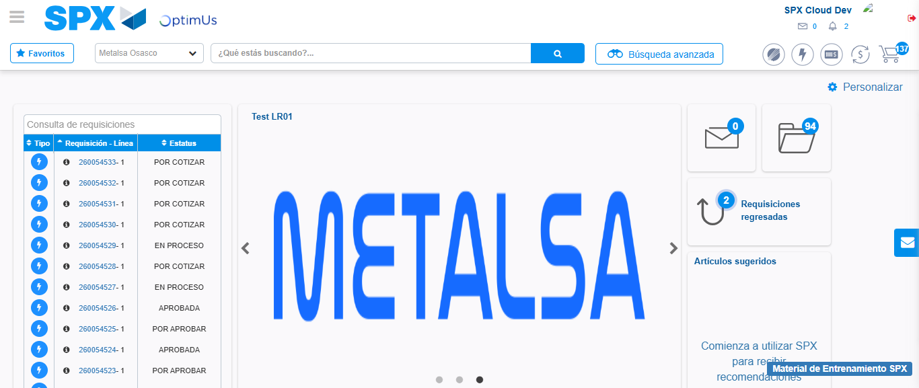Image file-name: QC_Testing-tc003_SPX_Dev5_Crear_Requisicion_Spot_Tipo_Cobro_CC_Urgent-1782239881801

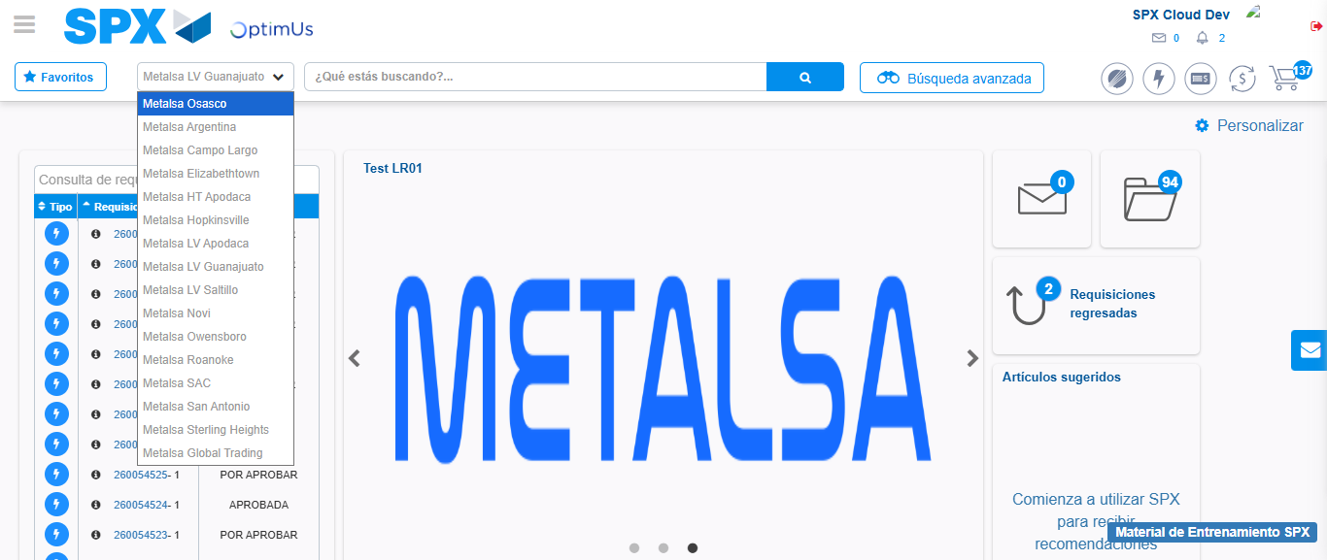Image file-name: QC_Testing-tc003_SPX_Dev5_Crear_Requisicion_Spot_Tipo_Cobro_CC_Urgent-1782239884747

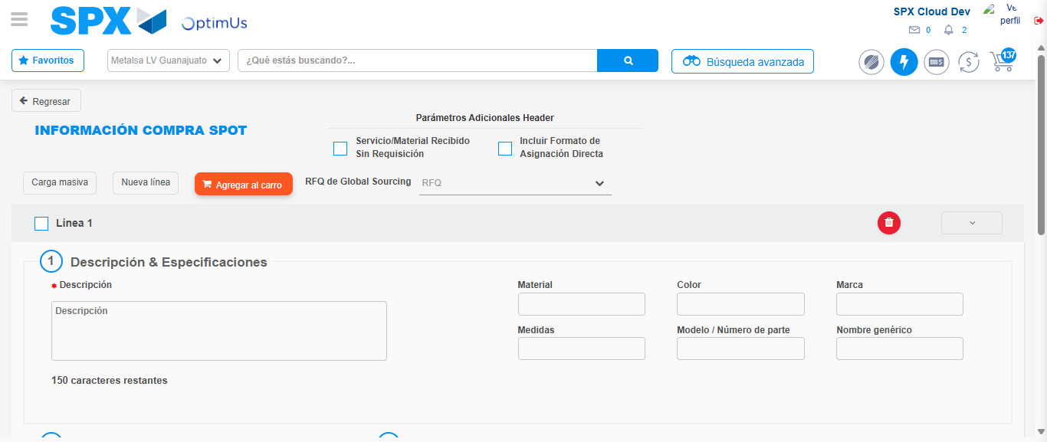Image file-name: QC_Testing-tc003_SPX_Dev5_Crear_Requisicion_Spot_Tipo_Cobro_CC_Urgent-1782239898822

Step 3 - Data Capture Spot Buy Requisition: Data captured correctly
Image file-name: QC_Testing-tc003_SPX_Dev5_Crear_Requisicion_Spot_Tipo_Cobro_CC_Urgent-1782239899093

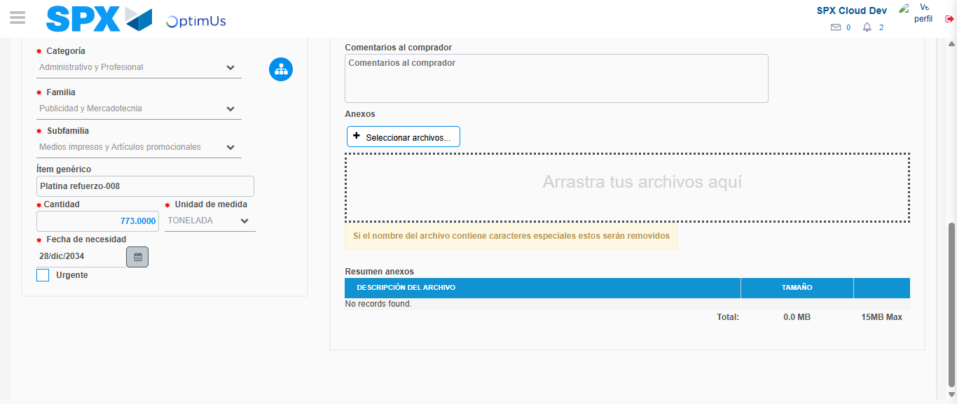Image file-name: QC_Testing-tc003_SPX_Dev5_Crear_Requisicion_Spot_Tipo_Cobro_CC_Urgent-1782239912686

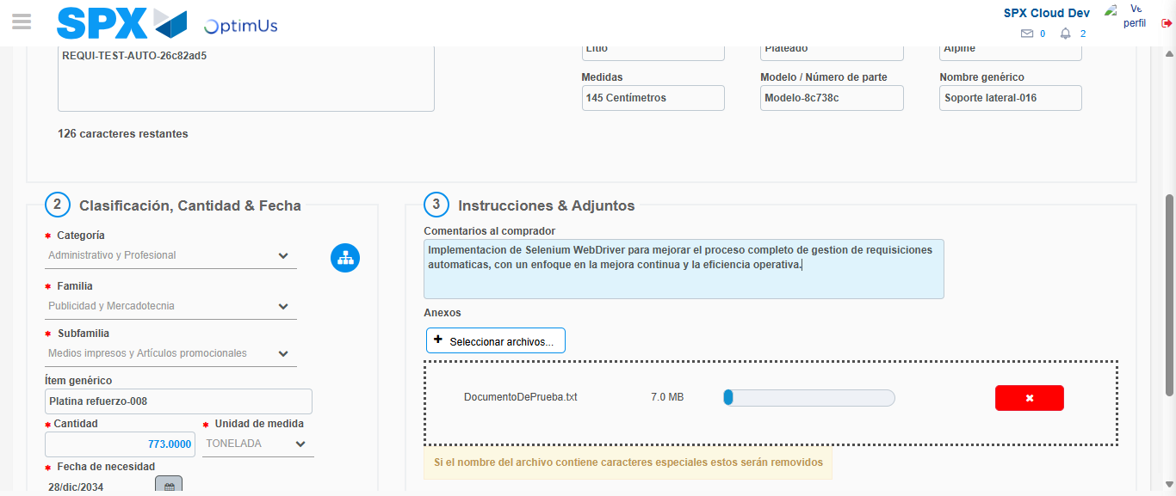Image file-name: QC_Testing-tc003_SPX_Dev5_Crear_Requisicion_Spot_Tipo_Cobro_CC_Urgent-1782239913721

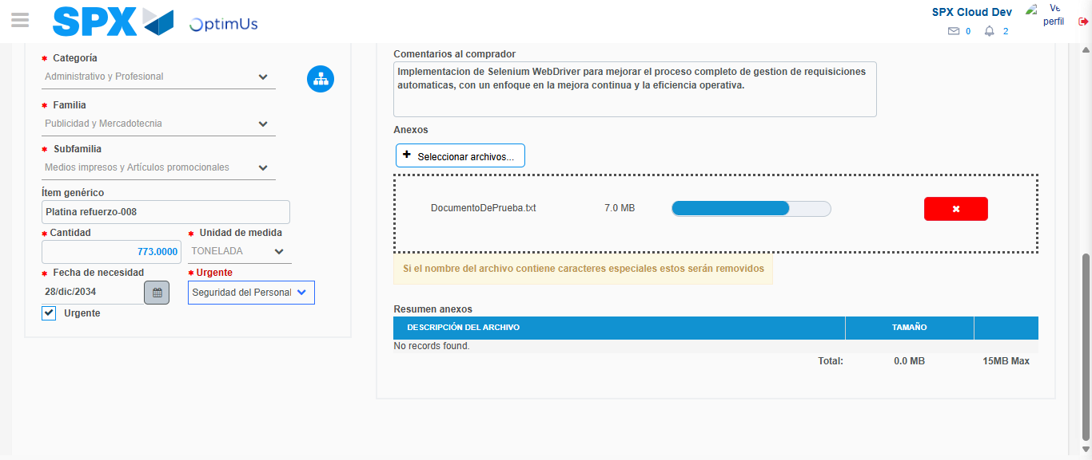Image file-name: QC_Testing-tc003_SPX_Dev5_Crear_Requisicion_Spot_Tipo_Cobro_CC_Urgent-1782239918277

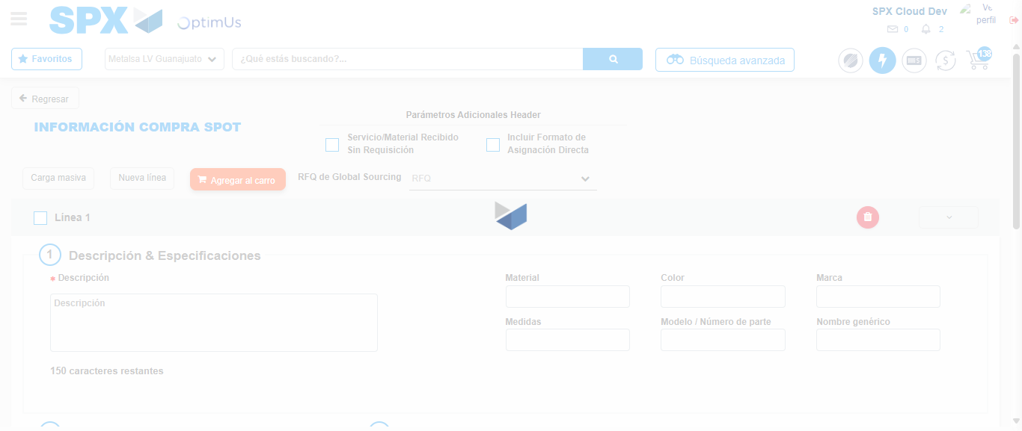Image file-name: QC_Testing-tc003_SPX_Dev5_Crear_Requisicion_Spot_Tipo_Cobro_CC_Urgent-1782239919878

Step 7 - Return to Main Page SPX : Return to Main Page SPX
Image file-name: QC_Testing-tc003_SPX_Dev5_Crear_Requisicion_Spot_Tipo_Cobro_CC_Urgent-1782239881801

Image file-name: QC_Testing-tc003_SPX_Dev5_Crear_Requisicion_Spot_Tipo_Cobro_CC_Urgent-1782239884747

Image file-name: QC_Testing-tc003_SPX_Dev5_Crear_Requisicion_Spot_Tipo_Cobro_CC_Urgent-1782239898822

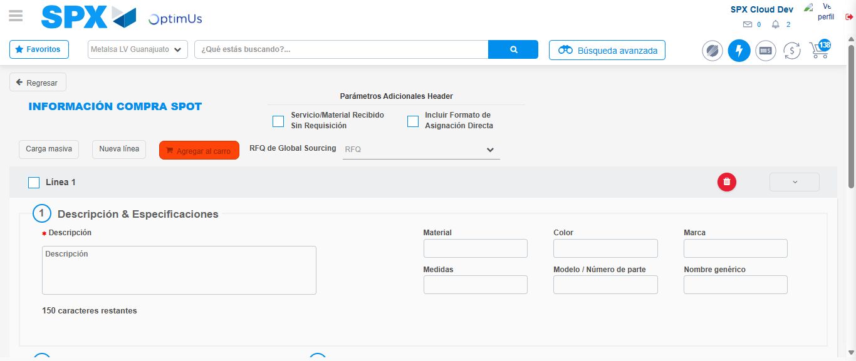Image file-name: QC_Testing-tc003_SPX_Dev5_Crear_Requisicion_Spot_Tipo_Cobro_CC_Urgent-1782239922187

Image file-name: QC_Testing-tc003_SPX_Dev5_Crear_Requisicion_Spot_Tipo_Cobro_CC_Urgent-1782239922363

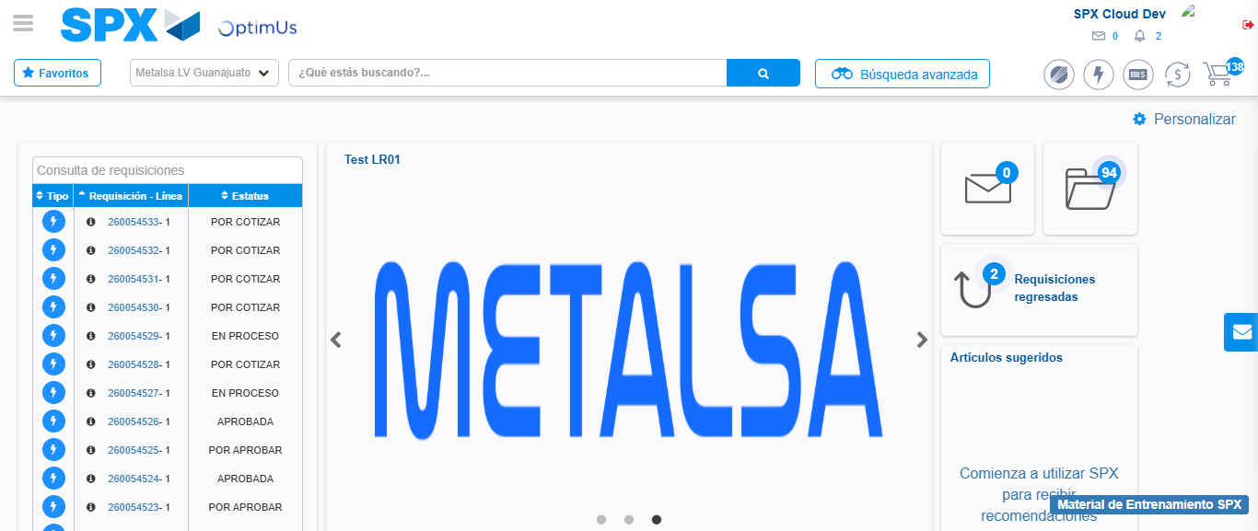Image file-name: QC_Testing-tc003_SPX_Dev5_Crear_Requisicion_Spot_Tipo_Cobro_CC_Urgent-1782239943826

Step 8 - Log Out : Log Out SPX
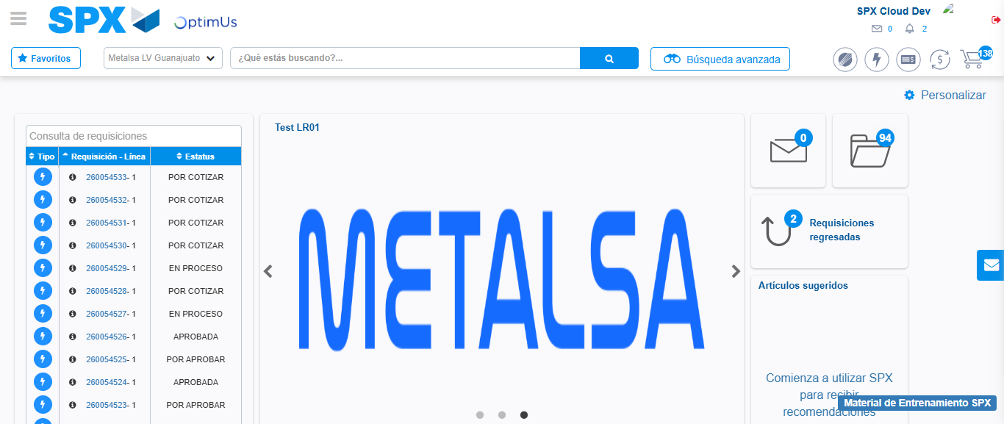Image file-name: QC_Testing-tc003_SPX_Dev5_Crear_Requisicion_Spot_Tipo_Cobro_CC_Urgent-1782239944213

